Name: Shubham Jha

Div: D15C

Roll No.19

**Experiment 1B: IAM and cloud9**

1.Open the AWS account and search for Cloud9. 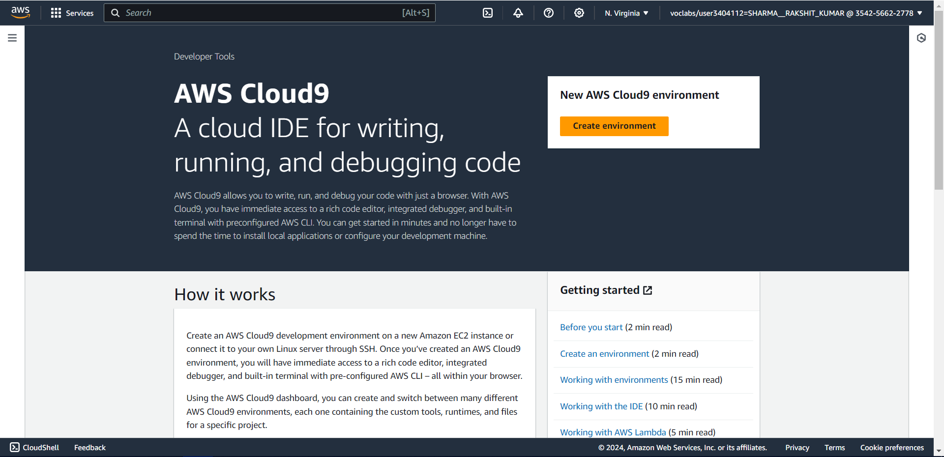

2. Enter the name and other required configuration for creating an environment. In network settings, using the AWS system manager gives an error while creating the environment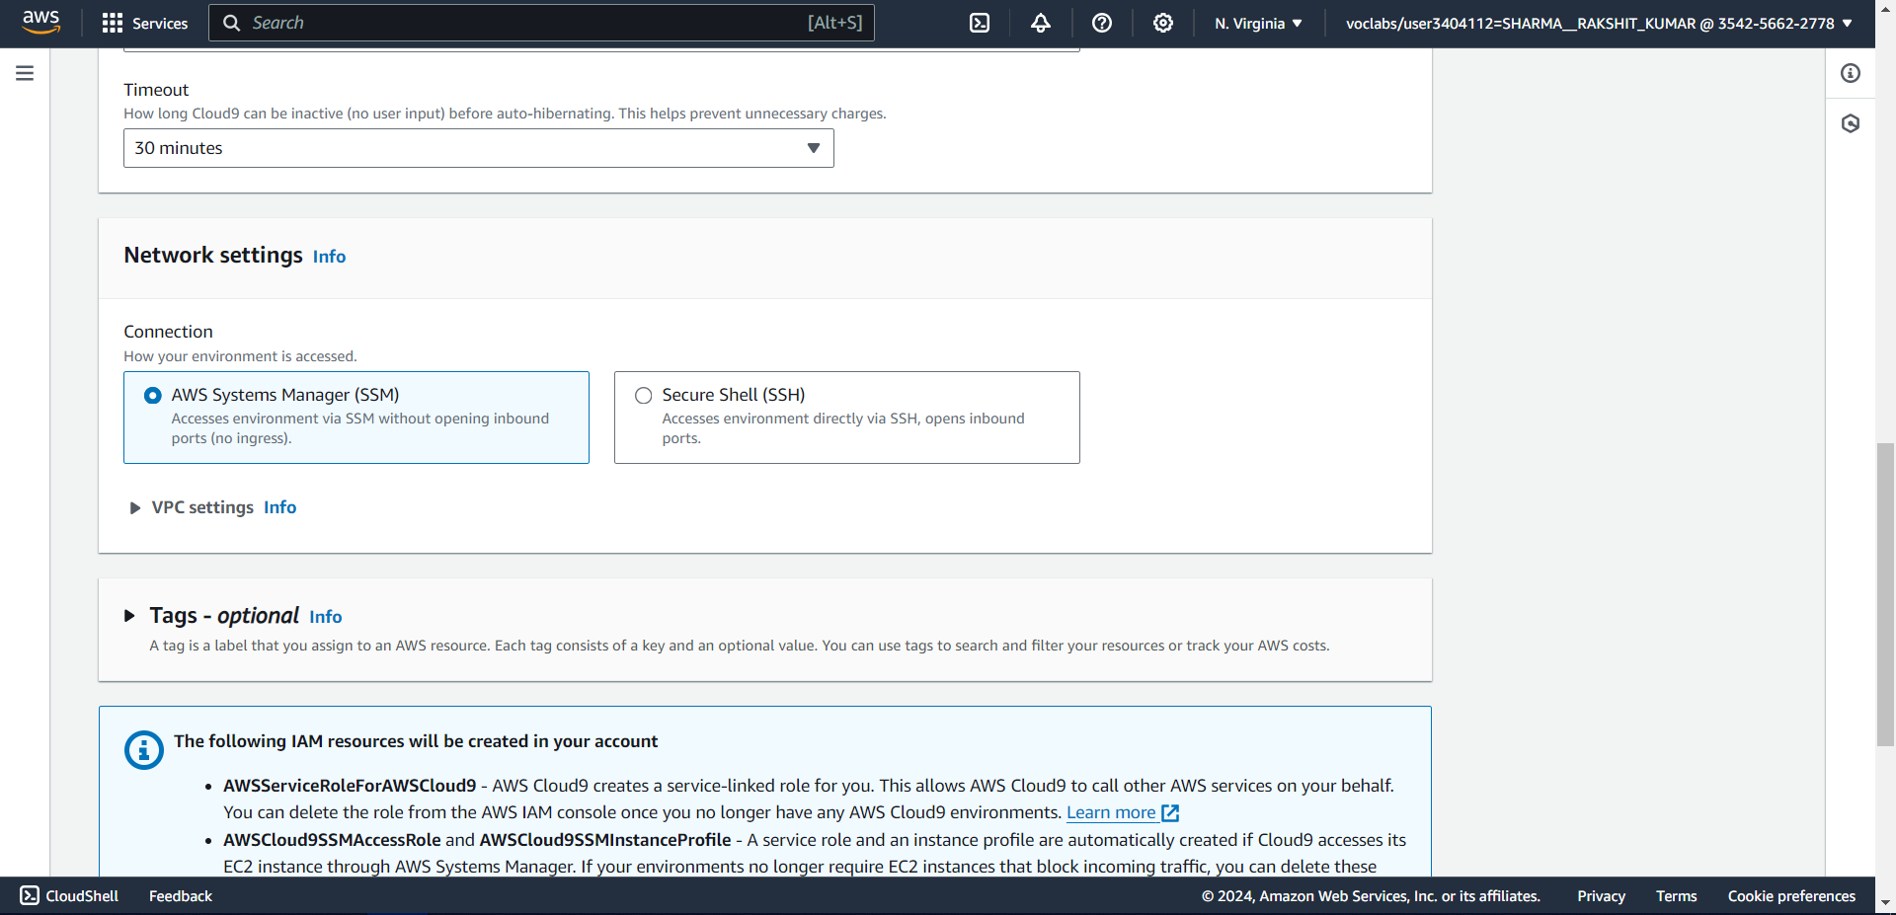

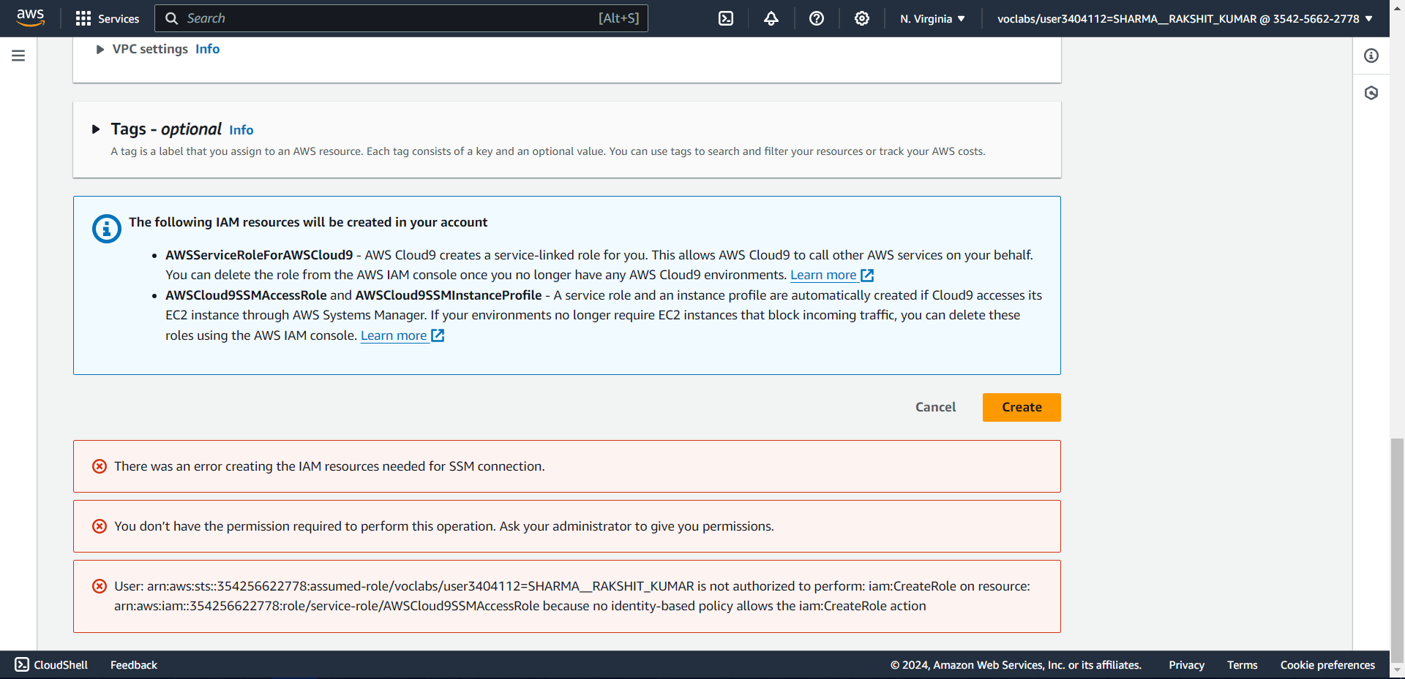

3. Use the Secure Shell option in Network settings.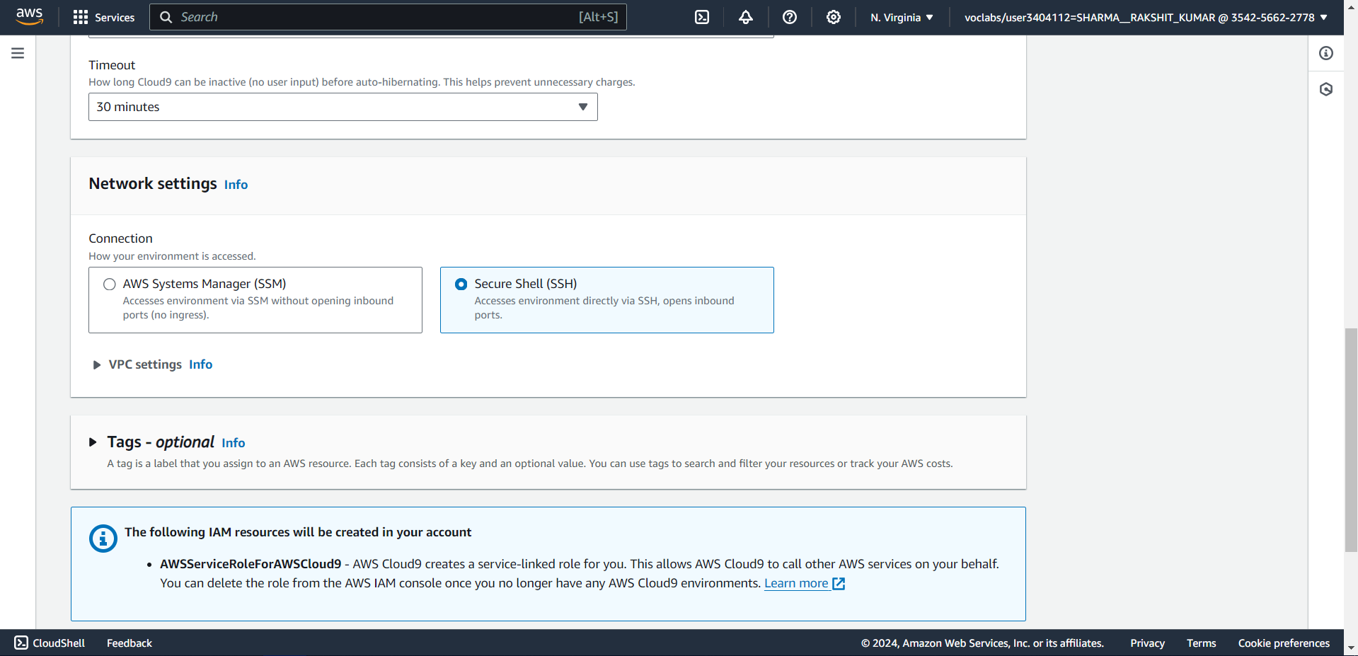

4. Once the configuration is complete, click on create environment to create a Cloud9 environment. 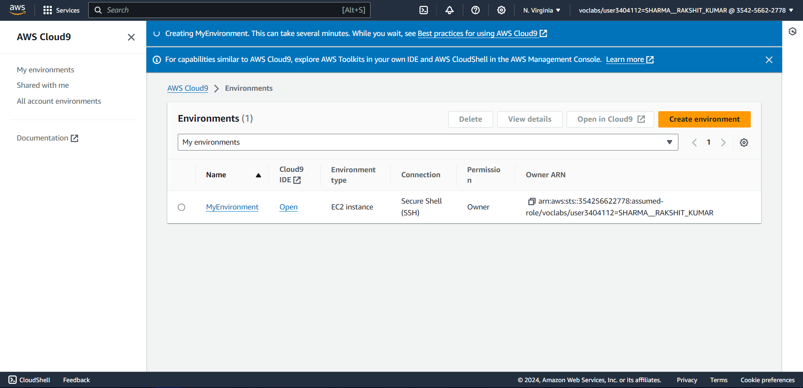

5. Cloud9 Environment.is opened when u click on the environment name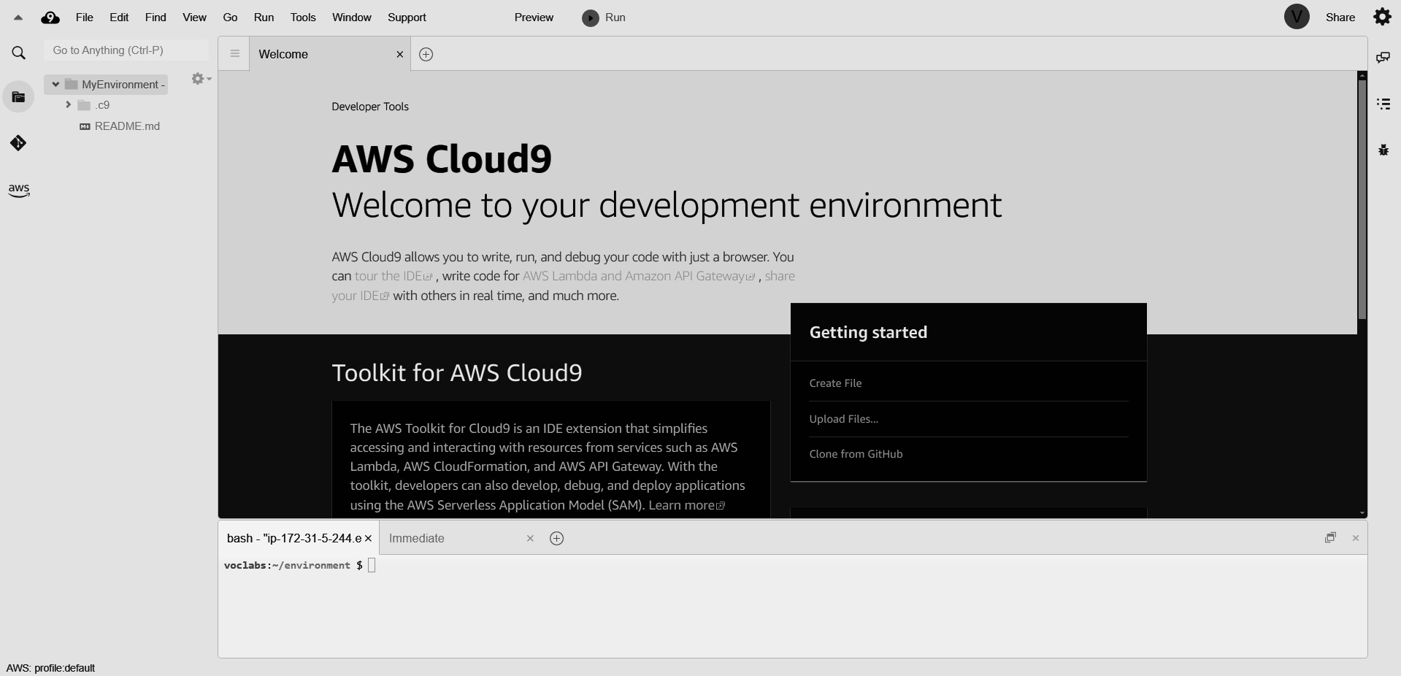

# IAM user creation:

1. Open the AWS account and search for IAM in service.

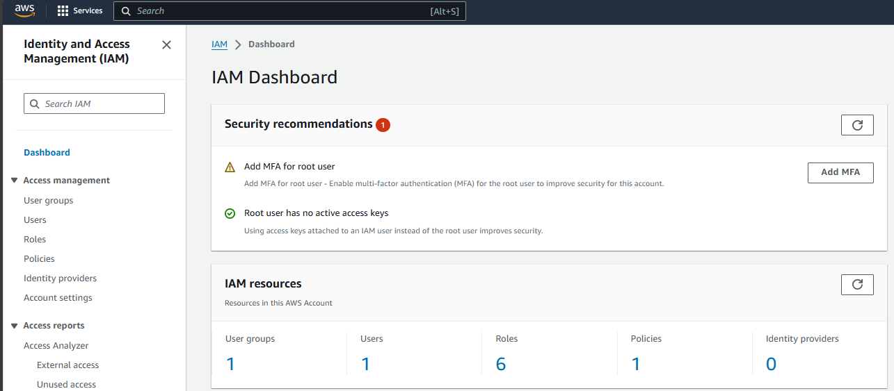

2. Select the users option from the left panel and click on create user button. Give the user name,

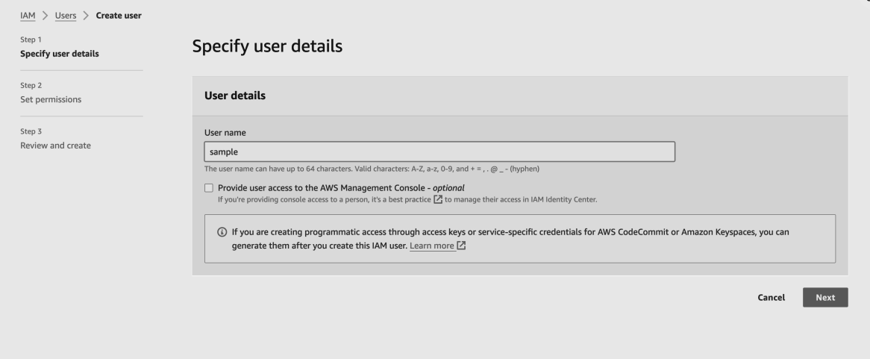

3. Click the add user option if you don't have an existing user group

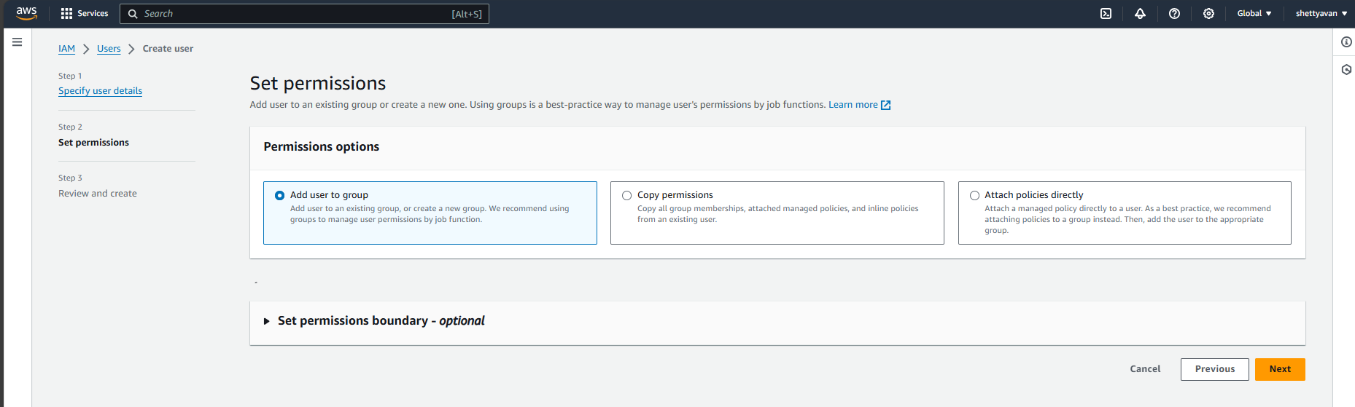

4. Give a name to your user group and check the policies if required any

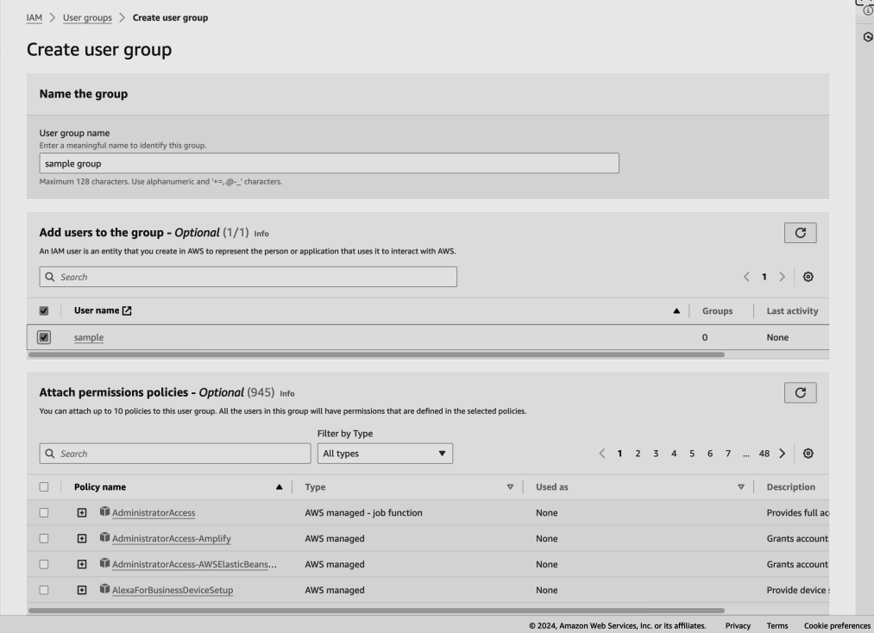

5. Once the user group is created, select the name and click next to create your user

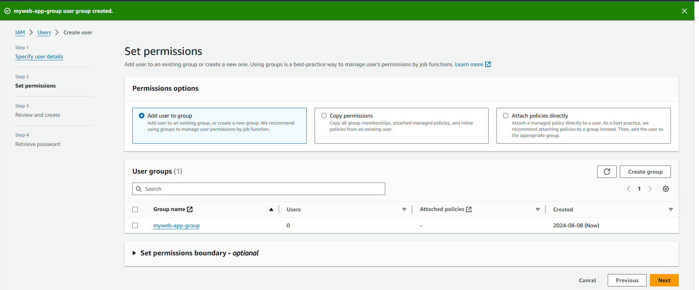

6. Review the configuration and then click on ‘Create user’ button

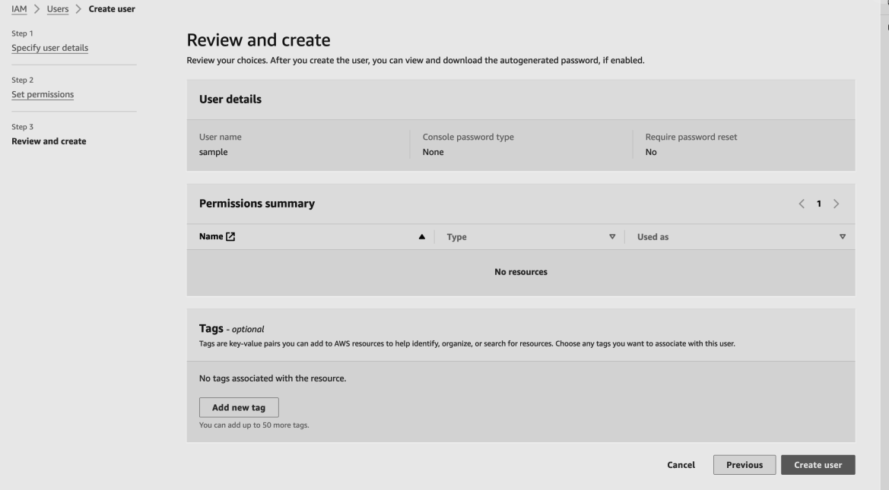

7. You will see the “user created successfully” message and incase you need then store your password by downloading the csv file

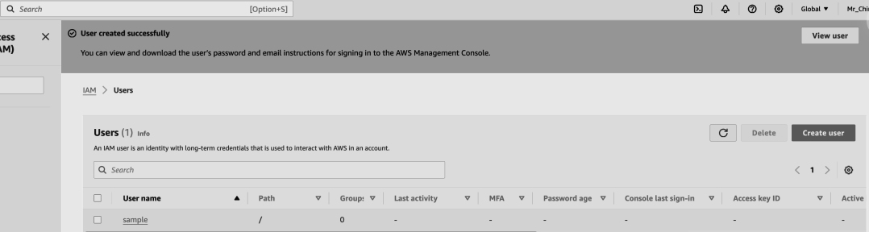

8. After creation of the user, go to the user groups tab and select the group in which the user has been added. Navigate to the permissions tab. Click on add permissions and attach policy.

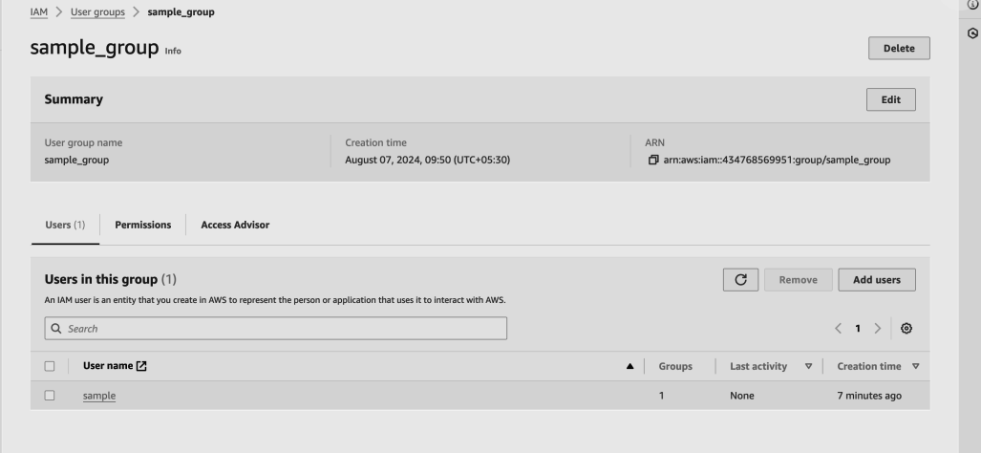

9. Search for the “AWSCloud9EnvironmentMember” policy and attach it.

